Tool Kit

“What Your Shelter Can Do to Prevent TB”

- “Assessing Your Shelter Guests’ Risk for TB”

- Cough Alert Policy

“Think TB” Materials

- Stop TB Poster
(laminated copies are available from TB Control: 287-8157)

Cover Your Cough Poster

(laminated copies are available from TB Control: 287-8157)

- Resources



What Your Shelter Can Do To Prevent TB

- Observe guests for signs of TB and facilitate a medical evaluation for individuals who are coughing for more than three weeks or who have other signs of TB

- Encourage guests who are being evaluated or treated for TB to follow through with treatment. Reassure them that TB treatment is free and that TB can be cured

- Move guests who are coughing to a separate sleeping area if possible

- Maintain as much space as possible between beds and position beds “head to toe” rather than “head to head”

- Maintain logs or “bed lists” and keep them for one year

- Think about ventilation: open doors and windows to promote air exchange, especially in areas where guests congregate to eat, sleep or watch TV. If your shelter has a mechanical ventilation system, be sure that it is functioning properly.

- Use ultra violet lights if they are available. UV lighting kills bacteria in the air

Provide education about TB for staff, guests and volunteers

- Post signs to promote “cough etiquette”

- Provide tissues and paper masks and use them for both staff and guests when they are coughing

- If your shelter serves “high risk” guests (See “Tool Kit” to determine risk), screen staff and guests for TB infection (tuberculin skin testing / “PPD”). Skin test screening needs to be provided by a health care worker who has had special training in administering and reading skin tests.

- Be aware that individuals who have HIV infection or other chronic diseases are more vulnerable to TB infection

- Develop a TB policy and keep it in a place where staff may refer to it when questions arise.

Assessing Your Shelter Guests’ Risk for TB

Below are some characteristics of shelter populations that may help you to determine if your shelter guests are “high risk” for TB. You may use this information to help make decisions about skin testing, symptom screening and what kind of education might be most helpful for your shelter. If you answer “yes” any of the following questions, your shelter population may be considered to be“high risk”.

Are your shelter guests:

- Single adults?
- Chemically dependent?
- Chronically ill?
- Frequently incarcerated?
- Chronically homeless?
- Coming to your shelter from urban areas outside of Maine?
- Coming to your shelter from other countries where TB is common?

Do your shelter guests sleep in a common sleeping area, where beds are closer than 6 feet apart?

Does your shelter population “turn over” more than once per week?

Is your shelter located in an urban setting?

Have there been TB cases in the community where your shelter is located?

Cough Alert Policy For Maine’s Homeless Shelters

Shelter staff play an important role in communicable disease detection and prevention. Staff who follow “Cough Alert Policies” help to find active cases of TB and prevent the spread of TB to others.

What to Look For

- Guests who are coughing through the night
- Guests who cough for more than three weeks without improvement
- Guests who have chronic cough and also have night sweats, fever, weight loss and/or blood in sputum (phlegm)

Cough Alert Check List

- Coughing throughout the night?
- Coughing more than 3 weeks?
- Coughing up blood?
- Weight loss?
- Fever lasting more than 3 weeks?
- Sweating at night that drenches clothes and bedding?

What to Do

- Ask the guest to cover his/her nose and mouth when coughing by using tissues and a mask
- Move the guest to a separate sleeping area, if possible
- Notify your supervisor and document the guest’s name, dates s/he stayed in the shelter and bed number
- Arrange for a medical evaluation for the guest within 48 hours
- Coughing up blood is s serious symptom that should be evaluated right away

*How to Arrange for a Medical Evaluation for TB:

- If your shelter has a nurse, ask the nurse to assess the guest
- If your shelter does not have a nurse or a doctor, utilize:
- The guest’s primary care provider, if s/he has one
- Health Care for the Homeless Program, or free clinic if one of these are available to your shelter
- Local community clinic or provider
- Hospital emergency room

*Call TB Control at 287-5194 for guidance if you suspect TB

 | THINK TB  FOR SHELTER GUESTS

The Maine Bureau of Health
urges you to THINK TB

Tuberculosis is spread by tiny germs that can float in the air

TB germs may spray into the air if a person with TB disease coughs, shouts or sneezes

If TB germs cause TB disease, the person needs medical help

If you have TB you may: feel weak, cough a lot, cough up blood, have chest pain when you cough, lose your appetite, lose weight, have a fever, or sweat a lot at night

Only a doctor can tell you if you have TB disease

Staff at this center can help you get a TB test

TB tests are free and confidential

TB is preventable and if you already have it, it can be cured



For more information, contact the Maine TB Control Office in Augusta at 1-800-821-5821 or (207) 287-5194
or visit the Maine DHHS, Bureau of Health’s Division of Disease Control website at http://www.mainepublichealth.gov

THINK TB
WHAT IS TB?

What is TB? “TB” is short for a disease called tuberculosis. TB is spread by tiny germs that can float in the air. TB germs may spray into the air if a person with TB disease of the lungs or throat coughs, shouts, or sneezes. Anyone nearby can breathe TB germs into their lungs and get a TB infection.
How do I know if I have a TB infection? A skin test is the only way to tell if you have a TB infection. You can have a TB infection without feeling sick. The germs are sleeping in your lungs. You can take medicine to keep the germs from growing. If you don’t take medicine, the TB germs may begin to grow and cause TB disease. If you have TB disease you need to take medicine to cure your TB. A nurse will bring you the medicine and the health department will pay for it.
How does the skin test work? The test is usually done on the arm. A small needle is used to put some testing material under the skin. In two or three days, a health care worker will check to see if there is a reaction to the test. The test is “positive” if a bump about the size of a pencil eraser or bigger appears on your arm. This bump means you probably have a TB infection and need to visit a doctor. Staff at this center can help you get a TB test. The test if free and confidential.
How do I know if I have TB disease in my lungs? An X-ray of your chest can tell if there is damage to your lungs from TB. Phlegm (“flem”) you cough up can also be tested to see if the TB germs are in your lungs. If you have TB disease in your lungs, you may:
- Feel weak  - Lose your appetite  - Have a fever  - Have a cough lasting longer than 3 weeks | - Cough up blood in phlegm (“flem”), mucus or blood  - Lose weight  - Sweat a lot at night

How does HIV infection affect TB? HIV helps TB germs make you sick by attacking the germ fighters in your body. If you are infected with HIV and with TB germs, you have a very big chance of getting TB disease. Talk to your health care worker about getting an HIV test. If you have HIV infection, get tested for TB infection at least once a year.

For more information, contact the Maine TB Control Office in Augusta at 1-800-821-5821 or (207) 287-5194
or visit the Maine DHHS, Bureau of Health’s Division of Disease Control website at http://www.mainepublichealth.gov

THINK TB
FOR HEALTH CARE PROVIDERS

The Maine Bureau of Health urges healthcare providers to “Think TB” when evaluating potential high-risk persons such as . . .

- Foreign-born from TB endemic areas
- Residents of long-term care facilities
- Homeless or incarcerated persons

- Those with or at risk for HIV infection
- Close contacts of persons with TB
- Injection drug users

Diagnosis of Latent Tuberculosis Infection

Background. In most U.S. populations, screening for TB is done to identify infected persons at high risk for TB disease who would benefit from treatment of TB latent infection and to identify persons with TB disease who need treatment. Screening should be done in groups for which rates of TB are substantially higher than for the general population. Clinicians should tuberculin test high-risk persons as part of their routine evaluation. Institutional screening is recommended for the staff of health care facilities, as well as for the staff and residents of long-term care institutions where TB cases are found or the case rates of TB are high. The Mantoux tuberculin skin test is the preferred method of screening for TB infection.

Tuberculin Skin Test. The Mantoux tuberculin skin test (TST) is used to determine whether a person is infected with Mycobacterium tuberculosis. Tuberculin skin testing is contraindicated only for persons who have had a necrotic or a severe allergic reaction to a previous tuberculin skin test. It is not contraindicated for any other persons, including infants, children, pregnant women, persons who are HIV infected, or persons who have been vaccinated with BCG. The Mantoux tuberculin skin test is the standard method of identifying persons infected with M. tuberculosis. Multiple puncture tests (MPTs) should not be used to determine whether a person is infected.

Administering the Tuberculin Skin Test. The Mantoux tuberculin test is performed by placing an intradermal injection of 0.1 ml of purified protein derivative (PPD) tuberculin containing 5 tuberculin units (TU) into the inner surface of the forearm. The injection should be made with a disposable tuberculin syringe, just beneath the surface of the skin, with the needle bevel facing upward. This should produce a discrete, pale elevation of the skin (a wheal) 6 mm to 10 mm in diameter. Institutional guidelines regarding universal precautions for infection control (e.g., the use of gloves) should be followed.

Interpreting Skin Test Results. A trained health care worker should read the reaction to the Mantoux tuberculin skin test 48 to 72 hours after the injection. The reading should be based on
THINK TB FOR HEALTH CARE PROVIDERS

a measurement of induration (swelling), not on erythema, or redness. The diameter of the induration should be measured perpendicularly to the long axis of the forearm. All reactions, even those classified as negative, should be recorded in millimeters. Some persons who have positive skin test results may have TB disease. The possibility of TB disease must be ruled out before treatment of latent TB infection is begun.

False Positive & Negative Reactions. The Mantoux tuberculin skin test is a valuable tool, but it is not perfect. False-positive and negative reactions do occur. There is no sure way to determine the true cause of the reaction.

Diagnosis of Tuberculosis Disease

When to Suspect Tuberculosis (TB). The symptoms of pulmonary TB include cough, chest pain, and hemoptysis; the specific symptoms of extrapulmonary TB depend on the site of disease. Systemic symptoms consistent with TB also include fever, chills, night sweats, easy fatigability, loss of appetite, and weight loss. TB should be considered in persons who have these symptoms. Persons suspected of having TB should be referred for a complete medical evaluation, which should include a medical history, a physical examination, a Mantoux tuberculin skin test, a chest radiograph, and any appropriate bacteriologic or histologic examinations. A positive bacteriologic culture for M. tuberculosis confirms the diagnosis of TB. However, if TB disease is not ruled out, treatment should be considered. Please report all suspect and confirmed cases of TB to the Maine TB Control Office.

Diagnostic Laboratory Tests. The presence of acid-fast bacilli (AFB) on a sputum smear often indicates TB. Acid-fast microscopy is easy and quick, but it does not confirm a diagnosis of TB because some acid-fast bacilli are not M. tuberculosis. Therefore, a culture is done to confirm the diagnosis. Culture examinations should be done on all specimens, regardless of AFB smear results. Treatment should not be initiated until specimens have been submitted to the laboratory. Laboratories should report positive smears and positive cultures within 24 hours by telephone or fax to the primary health care provider and the TB control program. For all patients, the initial M. tuberculosis isolate should be tested for drug resistance. It is crucial to identify drug resistance as early as possible in order to ensure appropriate treatment. For this reason, we require all laboratories to submit clinical isolates of M. tuberculosis to the Maine Health and Environmental Testing Laboratory (287-2727) for drug susceptibility testing.

Who to call and why. . .

To report a suspect laboratory & clinical TB case: Contact the State of Maine TB Control Office at 1-800-821-5821 or (207) 287-5194.

For clinical consultation: Because of the potential pubic health implications of a patient who receives inadequate or suboptimal therapy, the Maine TB Control Office, Bureau of Health, provides comprehensive services for persons with confirmed or suspect TB. These services are free to you and your patient, and include the following:
- Laboratory services for smear, culture and susceptibility studies.
- Medication for patients with disease.
- Referral for HIV Testing – HIV Testing is recommended for all TB suspects/cases by the CDC’s TB Surveillance and Prevention Program and the American Thoracic Society.
THINK TB FOR HEALTH CARE PROVIDERS

- Directly Observed Therapy by Public Health Nurse for patients with disease.
- Treatment of TB latent infection (e.g. INH) for infected individuals.
- Public health nursing services to ensure follow-up of patients being treated for TB; delivery of medications; assistance with contact screening investigations etc.
- Educational materials for the primary care physician including CDC/ATS national guidelines on treatment.
If your patient, who is suspect or diagnosed TB disease, does not have access to third party insurance and is unable to pay for TB follow-up services, the TB Control Office in the Bureau of Health will provide resources for TB clinic services to a TB suspect or case at any one of the six state tuberculosis clinics located statewide.

For more information, contact the Maine TB Control Office in Augusta at 1-800-821-5821 or (207) 287-5194
or visit the Maine DHHS, Bureau of Health’s Division of Disease Control website at http://www.mainepublichealth.gov

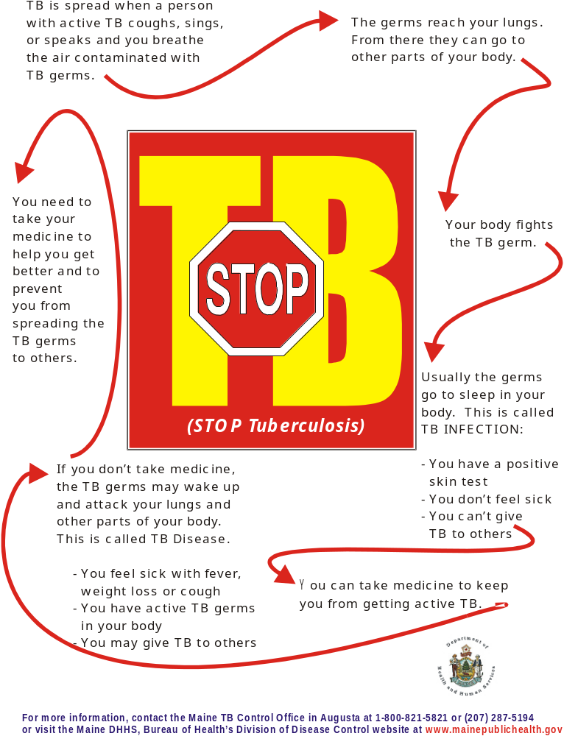
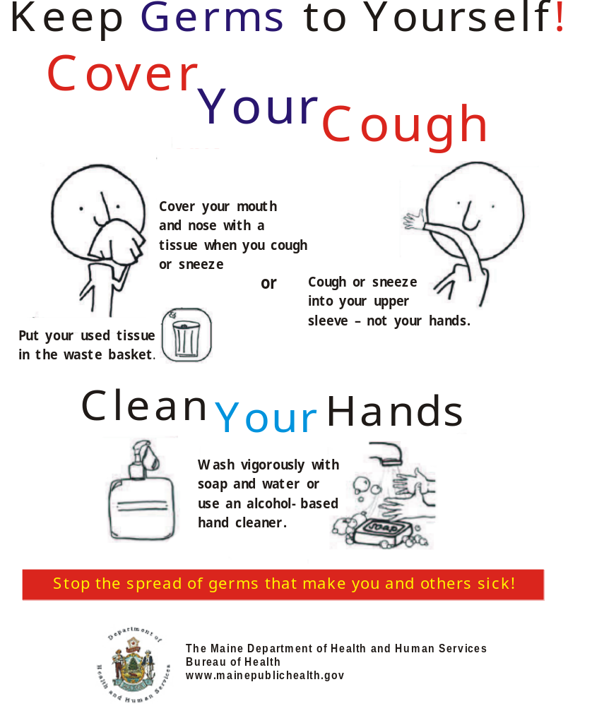

Resources

- To arrange for TB shelter education or needs assessment, call BOH Public Health Nursing at 207-287-5394

- Need help developing a TB Policy? Call TB Control: 207-287-5194

- TB Control: for information, support and “trouble shooting”: please call TB Control: 207-287-5194

- Maine Bureau of Health, Tuberculosis Web Site:

  - www.maine.gov/dhhs/boh/ddc/tuberculosis.htm

- Portland Public Health Division Outreach Nurse: 756-8343

- Maine State Housing Authority: 1-800-452-4668

